Good morning!

We are on track to have a phenomenal event.

I'm excited that you're both participating, and taking on one of the roles that I always find sets the stage for a fun and congenial event.

**Here's what you'll need to know/do.:**

**Arrive**: 7:45 or 7:30 to help set up the front table and get organized

**Money** and shoebox (or similar) will be there. We'll have about $200 in singles, fives and tens.

**Outside**: you'll be seated outside, best to bring a layers and sunglasses.

**RSVP** list: roughly 40 people have RSVPd. There will be a separate list of those individuals and they will have a badge.

**Dignitaries** list: 40 people including speakers and functionaries. There is a separate list and badges for them. I've also made a sign for them (see attached).

**General** checkin for non-registered individuals is different. They must first get a badge before coming in.

**Agenda:** Will be on the registration tables

**Tickets**: Red, ask people to put their names on their tickets.

**Role:**

Your role is half greeter, half money taker/checkin.

There will be signs, rsvp lists, badges and tickets, cash...

**Opportunity Drawing.**

There are three prices differences for the opportunity drawing. With the goal of getting people to round up! (see attached)

**Basically:**

RSVPs pay $5 and get 2 tickets

Functionaries and dignitaries need to buy their tickets, but get in free

General public pay $7 and get 1 ticket

Here's where it gets fun.

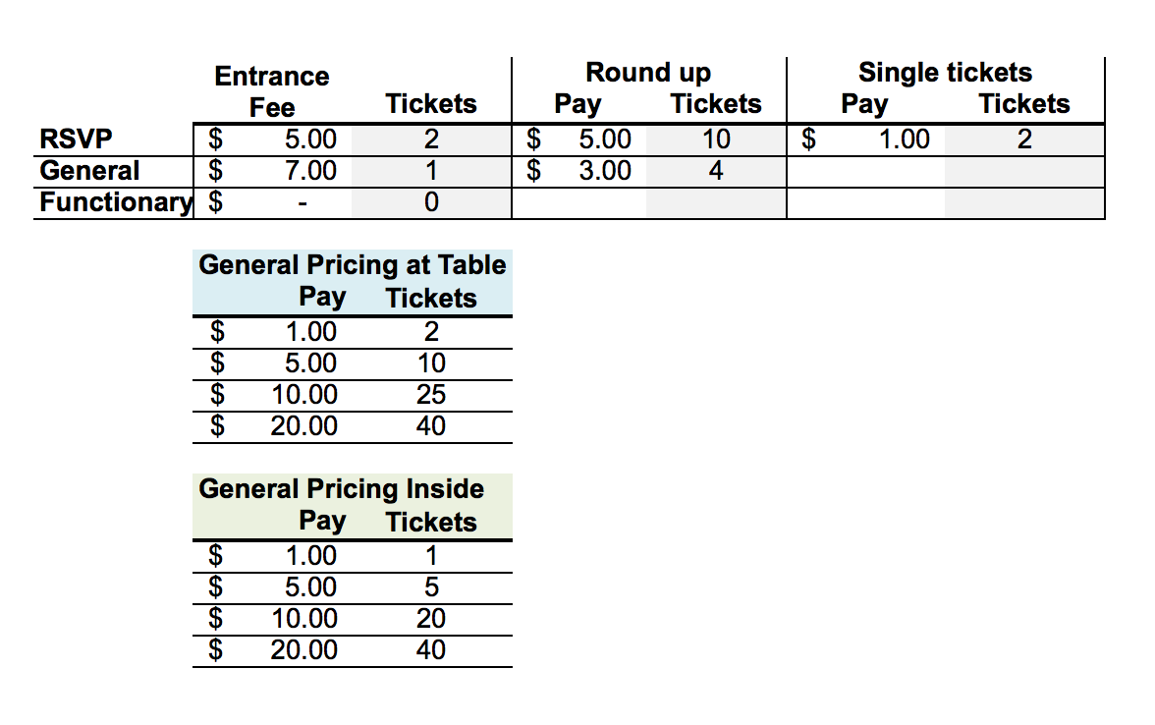

I'll have print outs for you. Attached are the various documents that are associated with your role.

- I will likely revise the signin to make it easier with the RSVPs.

Send me questions if you have them.